Command line Tools to monitoring Linux performance

1. **Top – Linux Process Monitoring**

* Linux **Top** command is a performance monitoring program.
* It display **CPU usage**, **Memory usage**, **Swap Memory**, **Cache Size**, **Buffer Size**, **Process PID**, **User**, **Command**s and much more
* It also shows high **memory** and **cpu** utilization of a running processes
* 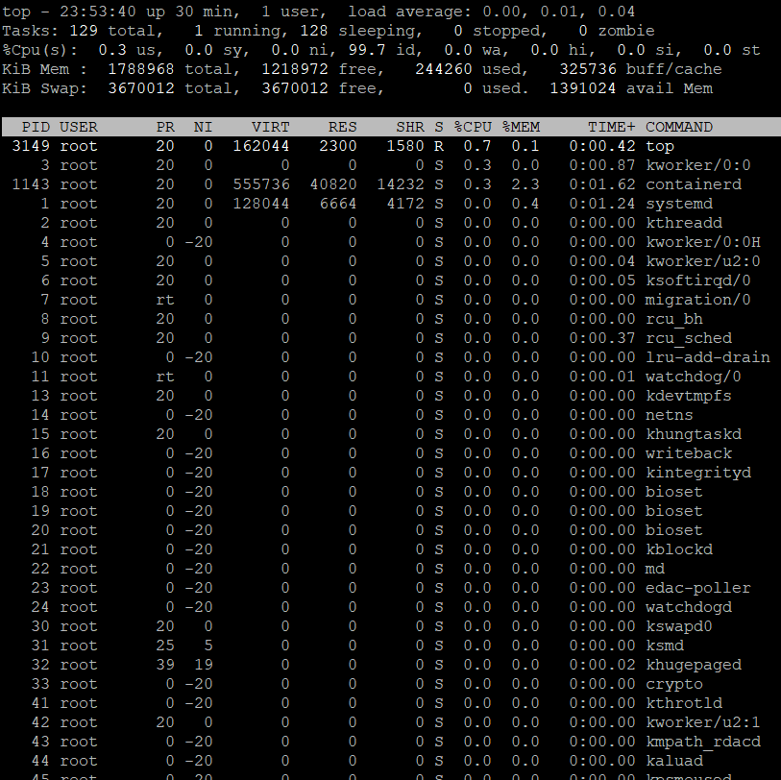

#### VmStat – Virtual Memory Statistics

#### used to display statistics of ****virtual memory****, ****kernerl threads****, ****disks****, ****system processes****, ****I/O blocks****, ****interrupts****, ****CPU activity**** and much more

#### By default vmstat command is not available under Linux systems you need to install a package called ****sysstat**** that includes a vmstat program

#### 

#### Lsof – List Open File

#### used to display list of all the open files and the processes.

#### The open files included are ****disk files****, ****network sockets****, ****pipes****, ****devices**** and ****processes****

#### One of the main reason for using this command is when a disk cannot be unmounted and displays the error that files are being used or opened. With this command you can easily identify which files are in use.

#### Tcpdump – Network Packet Analyzer

#### one of the most widely used command-line ****network packet analyzer**** or ****packets sniffer**** program that is used capture or filter ****TCP/IP**** packets that received or transferred on a specific interface over a network

#### Netstat – Network Statistics

#### ****Netstat**** is a command line tool for monitoring ****incoming**** and ****outgoing network**** packets statistics as well as interface statistics

#### **It is also used to check whether specific port is in listening or not.**

#### Htop – Linux Process Monitoring

#### ****Htop**** is a much advanced interactive and real time Linux process monitoring tool

#### This is much similar to Linux ****top command**** but it has some rich features like ****user friendly interface to manage process****, ****shortcut keys****, ****vertical and horizontal view of the processes**** and much more.

#### Htop is a third party tool and doesn’t included in Linux systems, you need to install it using ****YUM**** package manager tool. For more information on installation read our article below.

#### Iotop – Monitor Linux Disk I/O

#### ****iotop**** is also much similar to ****top command**** and ****Htop program****, but it has accounting function to monitor and display real time ****Disk I/O**** and ****processes****.

#### Iostat – Input/Output Statistics

#### ****IoStat**** is simple tool that will collect and show system ****input**** and ****output**** storage device statistics

#### This tool is often used to trace storage device performance issues including ****devices****, ****local disks****, ****remote disks**** such as ****NFS****.

#### IPTraf – Real Time IP LAN Monitoring

#### ****IPTraf**** is an open source console-based real time network (****IP LAN****) monitoring utility for ****Linux****

#### it collects a variety of information such as IP traffic monitor that passes over the network, including TCP flag information, ICMP details, TCP/UDP traffic breakdowns, TCP connection packet and byne counts. It also gathers information of general and detaled interface statistics of TCP, UDP, IP, ICMP, non-IP, IP checksum errors, interface activity etc.

#### Psacct or Acct – Monitor User Activity

#### psacct or acct tools are very useful for monitoring each users activity on the system.

#### Both daemons runs in the background and keeps a close watch on the overall activity of each user on the system and also what resources are being consumed by them.

#### Monit – Linux Process and Services Monitoring

#### ****monit**** is a free open source and web based process supervision utility that automatically monitors and managers system processes, programs, files, directories, permissions, checksums and filesystems.

#### It monitors services like Apache, MySQL, Mail, FTP, ProFTP, Nginx, SSH and so on. The system status can be viewed from the command line or using it own web interface.

#### NetHogs – Monitor Per Process Network Bandwidth

#### ****NetHogs**** is an open source nice small program (similar to Linux ****top command****) that keeps a tab on each process network activity on your system

#### It also keeps a track of real time network traffic bandwidth used by each program or application.

#### iftop – Network Bandwidth Monitoring

#### ****iftop**** is another terminal-based free open source system monitoring utility that displays a frequently updated list of network bandwidth utilization (source and destination hosts) that passing through the network interface on your system

#### iftop is considered for network usage, what ‘****top****‘ does for CPU usage